**Lab 7**

**Name:** Trần Gia Khôi

**ID:** ITITIU21231

**Exercise 5: Advanced Search**

**Task 5.1: Multi-Criteria Search**

Add advanced search method to ProductService and ProductServiceImpl





Add advanced search in ProductController

**Workflow:**

1. Browser → GET /products /advanced-search

2. ProductController receives request (@GetMapping)

3. Controller calls productService.advanceSearchProducts()

4. Service calls productRepository.searchProducts()

5. JPA automatically queries database

6. Repository returns List<Product>

7. Controller adds data to Model

8. Returns view name "product-list"

9. Thymeleaf renders HTML

10. Response sent to browser

**Task 5.2: Category Filter**

For filtering categories, we need to have two methods findByCategory() and findAllCategories() in ProductRepository

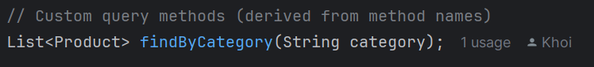



Define the getProductsByCategory() and categoryFilter() in ProductService and implement that method in ProductServiceImpl



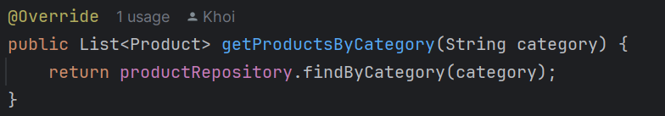



Then called them in ProductController

**Workflow:**

**User selects “Electronics” from the dropdown**

1. Browser → GET /products /filter?category=Electronics

2. ProductController receives request (@GetMapping)

3. Controller calls productService.categoryFilter()

4. Controller evaluate the **if** condition

5. Controller calls productService.getProductsByCategory(“Electronics”)

6. Service calls productRepository.findByCategory(“Electronics”)

7. JPA automatically queries database

8. Repository returns List<Product>

9. Controller adds data to Model

10. Returns view name "product-list"

11. Thymeleaf renders HTML

12 . Response sent to browser

**Task 5.3: Search with Pagination**

Modify method in ProductRepository to use Pageable



Also modifying the Service



**Workflow:**

**User types “iPhone” in the search box and click “Search”, or click “Page 2” at the bottom of the search result**

1. Browser 🡪 GET /search?keyword=iPhone&page=1&size=10

2. ProductController receives request (searchProducts() method)

3. Controller creates Pageable object

4. Controller calls Service

5. Service calls Repository

6. JPA executes Database query

7. Repository returns Page<Product>

8. Controller extracts data for the View

9. Controller adds attributes to Model

10. Thymeleaf renders product-list.html

**Exercise 6: Validation**

**Task 6.1: Add Validation Annotations**

Validation annotations added

**Task 6.2: Add Validation in Controller**

Controller updated, which is saveProduct() method (POST request)

**Task 6.3: Display Validation Errors**

**Exercise 7: Sorting & Filtering**

**Task 7.1: Add Sorting**

Sorting name in ascending order

Sorting name in descending order

**Workflow:**

**User sorting products by name (ascending)**

1. Browser 🡪 GET /products?sortBy=name&sortDir=asc

2. ProductController receives request

3. Controller creates Sort object

4. Controller calls productService.getAllProducts(sort)

5. Service calls productRepository.findAll(sort)

6. JPA generates SQL

7. Database execute query

8. Repository returns List<Product> (Sorted) 🡪 Service 🡪 Controller

9. Controller adds data to Model

10. Thymeleaf renders product-list.htlm

**Task 7.2: Filter by Category**

Define a findByCategory() method that contain the Sort object as parameter:



Implement that logic in ProductService and ProductServiceImpl



Then call it in ProductController:

By doing this, we make sure that sorting and filtering always doing together, not separating as before.

Filtering for “Electronics” and the result is as follows:

Then sorting for its name by ascending order

**Workflow:**

**User is viewing “Electronics” category and clicks the “Name” column header**

1. Browser 🡪 GET /products? sortBy=name&sortDir=asc &category=Electronics

2. ProductController receives request

3. Controller creates Sort object

4. Controller evaluates Filter condition

5. Controller calls Service

6. Service calls Repository

7. JPA executes Database query

8. Repository returns List<Product>

9. Controller adds data to Model

10. Thymeleaf renders product-list.html

**Exercise 8: Statistics Dashboard**

**Task 8.1: Add statistics methods**

**Task 8.2: Create Dashboard Controller**

DashboardController created

**Task 8.3: Create Dashboard View**

**Display:**

1. Total products count

For this feature, we can simply define a method in ProductService and implement this method in ProductServiceImpl



The count() method is a built-in method in JPA

Then call it in controller



Result:

2. Products by category

For this feature, we use the method countByCategory() in ProductRepository



ProductService and ProductServiceImpl



By using HashMap data structure, we can easily mapping the number of products for each category

DashboardController



Result:

3. Total inventory value

To display inventory value, the custom method in ProductRepository is calculateTotalValue()



Method in ProductService and implementation in ProductServiceImpl



Call method in controller



Result:

4. Average product price

Custom method in ProductRepository

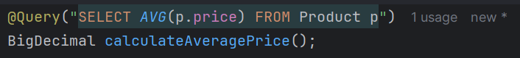

Method in ProductService and ProductServiceImpl



Call in controller



Result:

5. Low stock alerts

Custom method in ProductRepository



Define method in ProductService and ProductServiceImpl



Call method in DashboardController



Result:

6. Recent products

Custom method in ProductRepository



Method defined in ProductService and implementation in ProductServiceImpl



Call method in controller



Result:

**Workflow:**

**User visit the dashboard to view “Product Dashboard”**

1. Browser 🡪 GET /dashboard

2. DashboardController receives request (@GetMapping)

3. Controller calls productService.getTotalCount()

4. Service calls productRepository.count()

5. Controller calls productService.getTotalValue()

6. Service calls productRepository.calculateTotalValue()

7. Controller calls productService.getAveragePrice()

8. Service calls productRepository.calculateAveragePrice()

9. Controller calls productService.getLowStockProducts()

10. Service calls productRepository.findLowStockProducts()

11. Controller calls productService.getRecentProducts()

12. Service calls productRepository.findTop5ByOrderByIdDesc()

13. Controller calls productService.getCategoryDistribution()

14. Service calls productRepository.findAllCategories()

15. Service calls productRepository.countByCategory()

16. JPA automatically queries database

17. Repository returns number of products to display “Total Product”

18. Repository returns total value in number to display “Total Inventory Value”

19. Repository returns average price in number to display “Average Price”

20. Repository returns List<Product> to display product that has low quantity

21. Repository returns List<Product> to display product that has been added recently

22. Repository returns a Map that contains *key:value* pair to display the categories of product as well as quantity of each category

23. Controller adds data to Model

24. Thymeleaf renders dashboard.html